Exploratory Data Analysis – Practice Challenge

Introduction and Objectives
The aim of this project is to predict the next lap of a Formula 1 driver, in seconds, using only information from previous laps. The final project is intended to use race data from 2022-2025 Formula 1 seasons, using the FastF1 python library.
For this EDA, I decided to check overall seasons (2022-2025) data to understand which races can be valuable for the model and then a more detailed race data analysis, to understand in general, feature that may affect positively or negatively the model. In this race data, I used Monza 2024 race and 3 drivers from different positions: Leclerc, Verstappen and Alonso.
This EDA not only helps me understand which features are useful, but also features or moments that I will need to drop from the final dataset.

Data Description

Monza 2024 Race Data
Firstly, I checked the data to find drivers, whom did not finished the race or got lapped, to understand if it will be necessary to drop them and then I exported it into a csv file for better analysis. The csv file contains:
- 1008 lap records
- 20 drivers
- 32 columns
The dataset contains information on compounds, tyre life, stints, lap times, driver, team, pit entry and exit times, track status and in another file how the weather was in that moment.
I also decided to make lap time in seconds as it will be easier to analyse using a regression model.

Season Coverage
I also decided to save the calendars from 2022-2025 into a unique csv file to compare this seasons.
This data is divided into:
2022: 22 events
2023: 22 events
2024: 24 events
2025: 24 events
There are 25 distinct Grand Prix across this 4 seasons and of those 25, only 20 appear consistently in all four seasons.
These event with lower appearances have not been removed, as they can provide useful information for the dataset, however some of them, won’t be used for predictions as they have too little data.

Data Quality and Preparation

Missing Values
Missing values were investigated in the original Monza dataset before deciding whether rows or variables should be removed. LapTime, Compound and TyreLife contain no missing values in the Monza CSV.
Sector1Time contains 20 missing values. All of these occur on the first lap of each driver. The exact reason for this has not yet been confirmed, but from an assumption point of view it might be due to start of the race, the cars are too slow and this may not be counted as for an analytic point of view, this will ruin patterns.
SpeedFL contains 31 missing values. These missing observations all coincide with pit entry laps.
PitIn and PitOut times are also something to be careful, because when a driver enters the pits they will be, for example, in lap 60 and when they get out they will be in lap 61.

Exploratory Analysis Results

Lap Time Evolution During the Race
Question:
How do lap times change during the race, and how much do pit stops affect the observed pattern?
For this plot I used 3 different drivers (mentioned previously) as they were in different positions in the race.
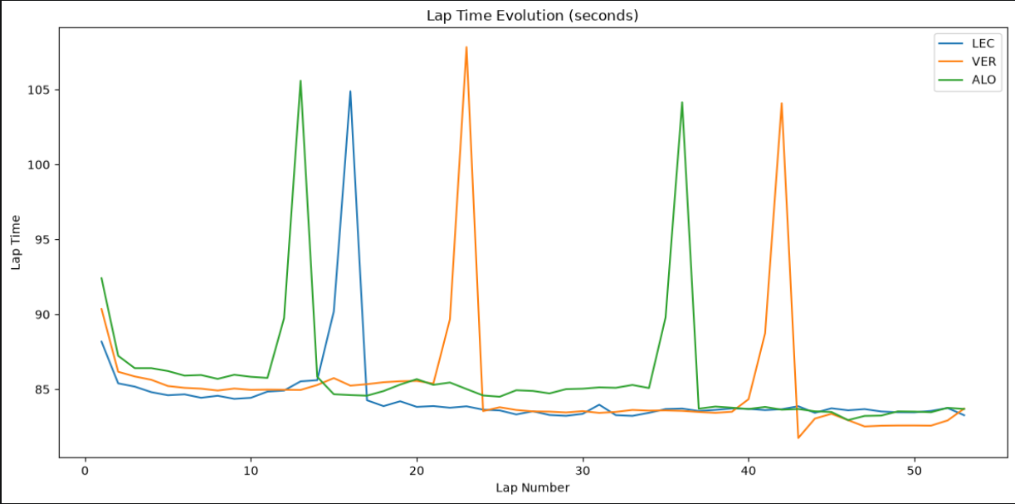
In this plot, we can see clear huge peaks in lap times. This is due to pit laps, as there are restrictions in the pits, making the cars go slower and lose time, in addition of the stop to change tyres. This makes it harder to find patterns, however we can see drivers used different strategies, so some will be faster or slower towards the end of the race
Due to this, the visualisation was therefore repeated after removing laps where PitInTime or PitOutTime was available.
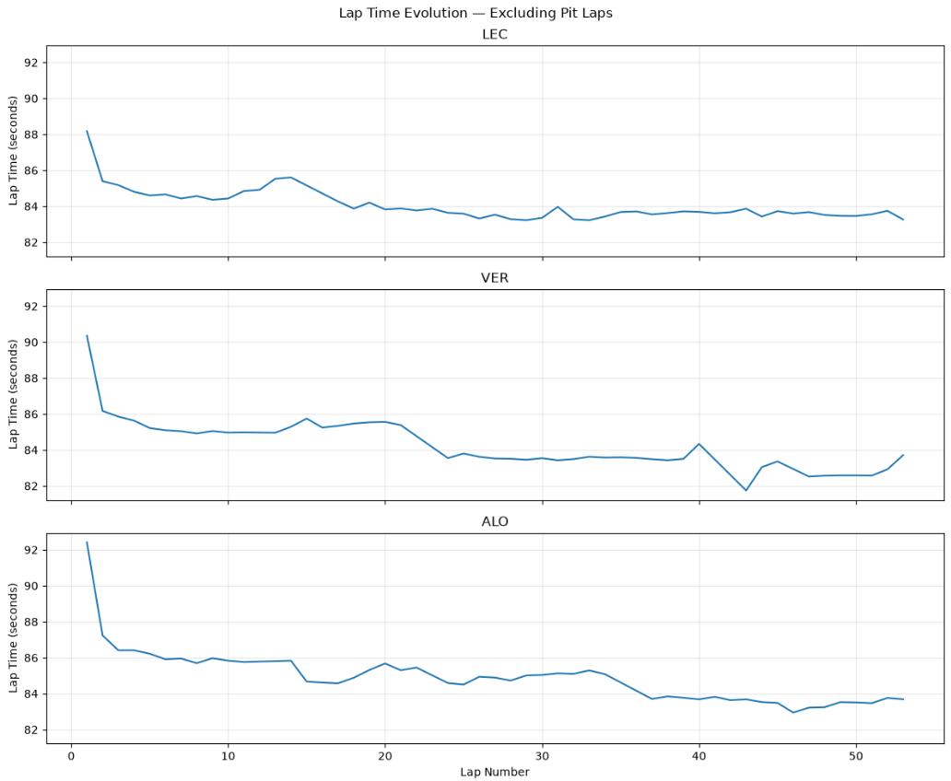
Here it is easier to find a pattern, however it is clearly visible that lap times are not totally linear.
The pattern does not follow one simple straight line throughout the race. However, this observation alone does not prove that a non-linear machine learning model will perform better.
The main decision from this is that pit laps should be treated differently and separately from the race of the race. However, I do not think we should delete them from the data.
4.2 Tyre Age
4.3 Air and Track Temperature
4.4 Tyre Compound Comparison
Implications for Modelling
Limitations
Conclusion

